Installation Of Git on CentOS

Before installing the git first we have to verify that git is not there
#git - - version
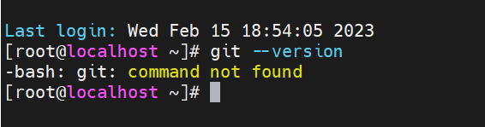

That means git is not installed on our system.
  - There is two ways to install the GIT on our system
- We have to download the source code and make a build and then we can install it.
- Using YUM, but its installed an older version of git
  - Option-1:- Installing latest version of git from IUS repository

Step-1:- Install Development Tools

Go to :- cd /etc/yum.repos.d
#yum group install “Development Tools”
Then run below command
#yum install gettext-devel openssl-devel perl-CPAN perl-devel zlib-devel

Step-2:- Now we are going to built

We have to download the package using wget command
If wget tool is not installed then first we have to install it

Installing wget tool
#yum install wget

After installing download the latest package of git, today date the latest version of git is 2.39.2
#wget https://www.kernel.org/pub/software/scm/git/git-2.39.2.tar.gz --no-check-certificate
After downloading Extract the file
#tar -xvf <File_name>
Once it extracts go into the file
#cd <file_name>

Now we have to buit the process

#make configure
Now we have to define where the built has to be saved
#./configure –prefix=/usr/local
#make install

Verify

#which git
#git - - version

